**Master Fuctional Document**

|  |  |
| --- | --- |
| **Application** | NGERP - Centra |
| **Service Bundle** | Master Management |
| **Service Request** | Currency |

**Description:**

In Compiere (NGERP – Centra), the Currency feature allows you to define currencies used for transactions and reporting. This enables the system to support financial operations in multiple currencies, ensuring consistency in global transactions and financial reports.

**Workflow Process:**

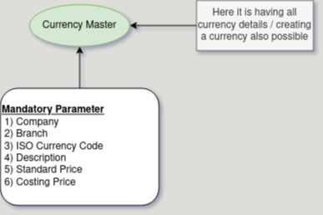

**Business Rules:**

* Currency data is visible in both HQ and ROW locations for global use.
* Creation of currencies are possible in both HQ and ROW.
* Add only the currencies you’ll use for transactions and reports.
* Currencies used across the system should be defined at the system level
* Deactivate currencies that are no longer needed to keep the system clean and accurate.